|  |
| --- |
| 新东方在线英语学习 |
| 新概念 1 册 |
| Lesson69-70 |



扫一扫。更多有趣的英语资讯。

# Lesson 69 单词讲解

1. year: 年

1998 年：in 1998

2013 年：in 2013

蛇年：the year of the snake si nai ke

今年：this year

去年：last year

今年是蛇年，去年龙年。

It is the year of the snake

and it was the year of the dragon.zhuai gen

1. race: 比赛

比速度- 汽车比赛、划船比赛、赛跑a car race, a boat race, a running race 球类比赛：match mai chi

a football match, a basketball match…

1. town: 城镇

village- town- city

1. crowd: 人群k ruai ao de

in the crowd

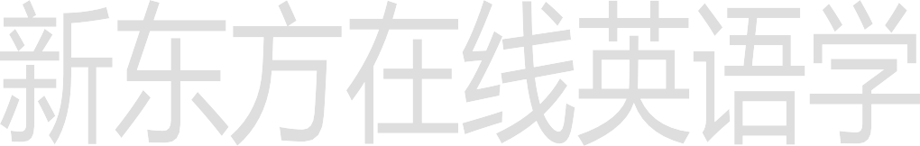a crowd of people

1. stand: 站立
2. exciting: 令人激动的ei ke si sai ting

The football match is exciting.

1. just
2. finish: 完成、结尾

v.

I must finish it on time. n.= end

It is a good finish(end) of the movie.

1. winner: 获胜者win- winner the first
2. behind: 后面

in front of : 前面

1. way: 路途
   1. on the way…

在去学校的路上： on the way to school

在回家的路上：on the way home

* 1. No way!
  2. By the way,…

# Lesson 69 课文讲解

1. There were hundreds of people there. hundred: 百

one hundred two hundred…

hundreds of… : 成百上千的thousands of…:上千上万的millions of…:不计其数的

1. My wife and I were at the race. You and I…

She\ he and I… Lucy, you and I

at the race: 在比赛现场

1. There were twenty cars in the race. in the race: 参加比赛
2. He was in car number 15.

15 号车 : car number 15(car 15) 10 号线 : Line 10

601 室 : Room 601

19 站台 : Platform 19…



5. 其他 5 辆车？

other five cars five other cars 其他两位老师:

two other teachers

1. On the way home…
2. My wife said to me, “…”. is-was

am-was are-were say-said

There be 句型的过去式

Hundred hang zhun de

Hundreds hang zhun zi

成百上千

# Lesson 69 语法讲解

1. 构成： There be+ (was, were)+地点

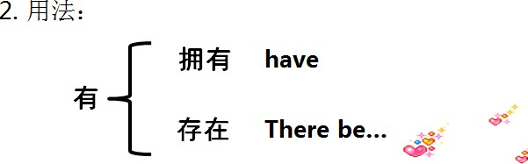

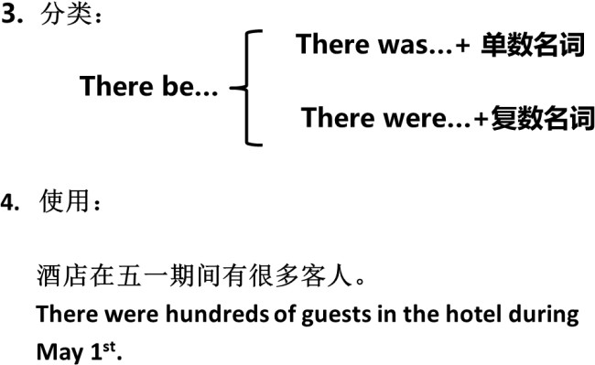

奥运会时北京的老外特别的多。

There were many foreigners in Beijing during the Olympic Games.

从前这里没有这么多的大楼。

There were not so many tall buildings here.

以往北京也有这么多地铁线吗？

Were there so many subway lines in Beijing?

Millions of mei lian zi

# Lesson 70 单词句型讲解

1. stationer: 文具商s dei shi ner

在文具店：at the stationer’s

在肉店：at the butcher’s

在蔬菜水果店：at the greengrocer’s

1. Denmark: 丹麦 den mark

Danish: 丹麦人dei nei shi

# Lesson 69&70 知识拓展

有关问路:

1. Excuse me. Can you tell me the way to…?
2. Excuse me. Do you know the way to…?
3. Excuse me. How can I get to…?
4. Excuse me. Where is…please?
5. 指路:
   1. 左转—turn left
   2. 右转—turn right
   3. 直行—go straight, go down
   4. 交叉路口—crossing，intersection

